Gmail SMTP

📧 What is Gmail SMTP?
# Source: AI Source: Provided by: [Data Path: Persons Table -> ID Column: 1, Name_En Column: Motasem Essam] -> From: [Chatgpt (GPT‑5 Mini)] on [1/21/2026]
Gmail SMTP is the outgoing mail server provided by Google that allows apps (like PHP, Python, or mobile apps) to send emails using a Gmail account.
In simple terms:
📬 SMTP is how your app delivers an email.
📡 Gmail SMTP is Google's server that handles this delivery for your Gmail account.

🔧 Gmail SMTP Server Details
# Source: AI Source: Provided by: [Data Path: Persons Table -> ID Column: 1, Name_En Column: Motasem Essam] -> From: [Chatgpt (GPT‑5 Mini)] on [1/21/2026]
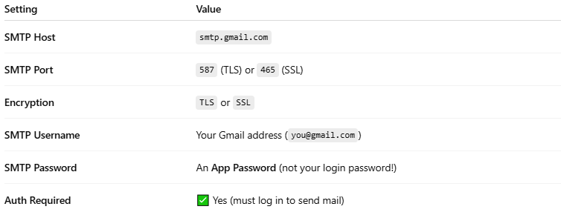

Setting | Value
SMTP Host | smtp.gmail.com
SMTP Port | 587 (TLS) or 465 (SSL)
Encryption | TLS or SSL
SMTP Username | Your Gmail address (you@gmail.com)
SMTP Password | An App Password (not your login password!)
Auth Required | ✅ Yes (must log in to send mail)

✅ Use Case
# Source: AI Source: Provided by: [Data Path: Persons Table -> ID Column: 1, Name_En Column: Motasem Essam] -> From: [Chatgpt (GPT‑5 Mini)] on [1/21/2026]
You can use Gmail SMTP to:
- Send emails from a PHP application (using PHPMailer or similar)
- Send form submissions (e.g. contact forms)
- Send alerts from a script running on localhost or a web server

🔐 Gmail Requires an App Password
# Source: AI Source: Provided by: [Data Path: Persons Table -> ID Column: 1, Name_En Column: Motasem Essam] -> From: [Chatgpt (GPT‑5 Mini)] on [1/21/2026]
Because of Google’s security:
- You must enable 2-Step Verification
- Then go to: https://myaccount.google.com/apppasswords
- Generate a password for "Mail"
- Use that password in your script

🔁 Example in PHPMailer
# Source: AI Source: Provided by: [Data Path: Persons Table -> ID Column: 1, Name_En Column: Motasem Essam] -> From: [Chatgpt (GPT‑5 Mini)] on [1/21/2026]
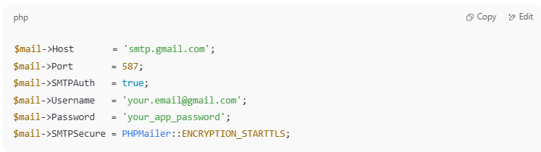

$mail->Host = 'smtp.gmail.com';
$mail->Port = 587;
$mail->SMTPAuth = true;
$mail->Username = 'your.email@gmail.com';
$mail->Password = 'your_app_password';
$mail->SMTPSecure = PHPMailer::ENCRYPTION_STARTTLS;

📬 Summary
# Source: AI Source: Provided by: [Data Path: Persons Table -> ID Column: 1, Name_En Column: Motasem Essam] -> From: [Chatgpt (GPT‑5 Mini)] on [1/21/2026]
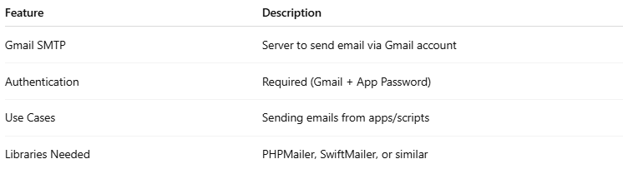

Feature | Description
Gmail SMTP | Server to send email via Gmail account
Authentication | Required (Gmail + App Password)
Use Cases | Sending emails from apps/scripts
Libraries Needed | PHPMailer, SwiftMailer, or similar

